|  |
| --- |
| NAME: Ayush Vinod Upadhyay  ROLL NO: I025  SAP ID: 60003220131  BRANCH: Information Technology  BATCH: 1 |

**EXPERIMENT NO – 11**

**Aim:** To implement Multithreading

**Problem Statement 1:** Write a multithreaded program a java program to print Table of Five, Seven and Thirteen using Multithreading (Use Thread class for the implementation.

CODE:

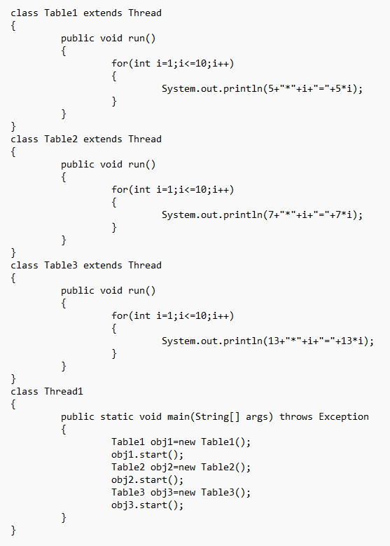

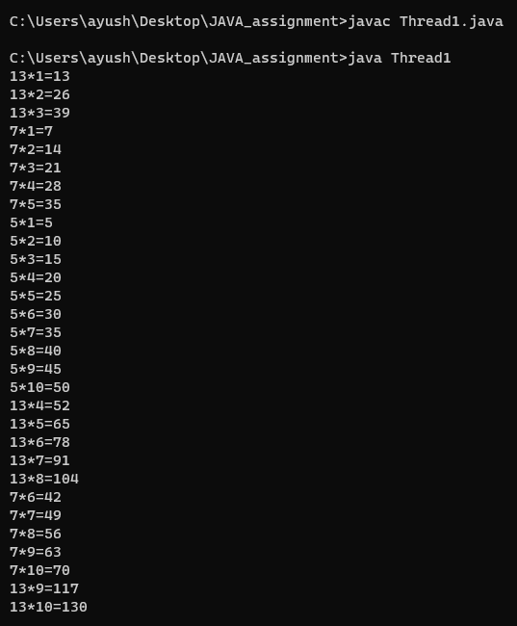

**Problem Statement 2:** Write a multithreaded program to display /*/*/*/*/*/*/*/* using 2 child threads.

CODE:

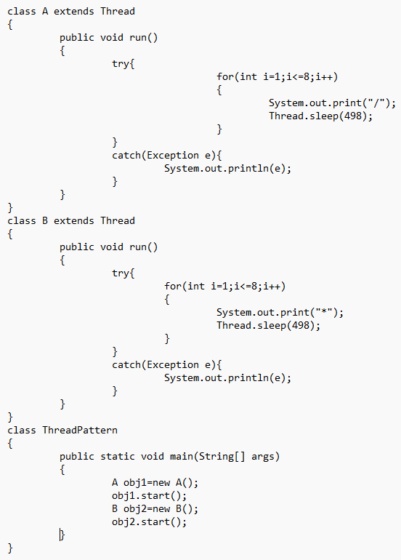

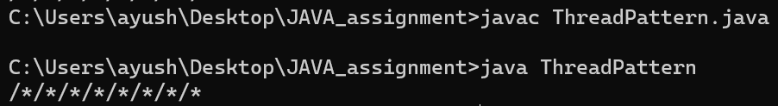

**Problem Statement 3:** Write a multithreaded program that generates the Fibonacci sequence. This program should work as follows: create a class Input that reads the number of Fibonacci numbers that the program is to generate. The class will then create a separate thread that will generate the Fibonacci numbers, placing the sequence in an array. When the thread finishes execution, the parent thread (Input class) will output the sequence generated by the child thread. Because the parent thread cannot begin outputting the Fibonacci sequence until the child thread finishes, the parent thread will have to wait for the child thread to finish.

CODE:

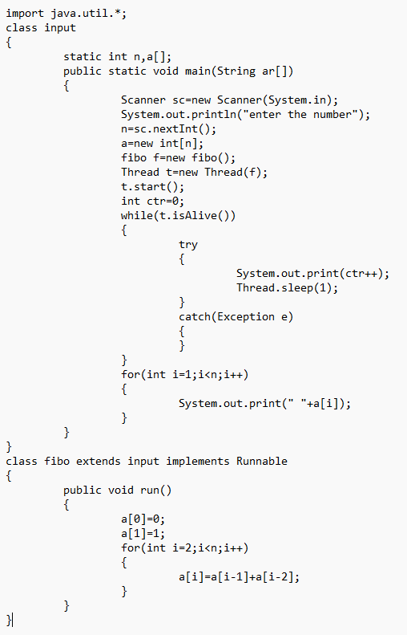

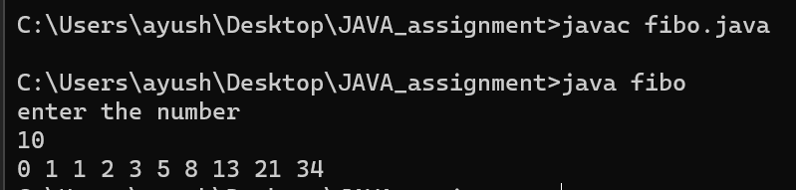

**Problem Statement 4:** WAP to prevent concurrent booking of a ticket using the concept of thread synchronization.

CODE:

